

**Asset Practice Answers: Mathematics**

1. The given figure shows the contents page of a Mathematics book.

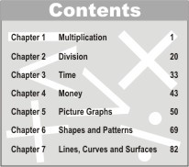

How many pages long is the chapter on *Shapes and Patterns*?

A. 82

B. 69

C. 27

**D. 13**

2. Manas is playing a computer game. Each time he plays the game, he either gets a star or a sparkie. He gets 5 points for a star and 10 points for a sparkie.

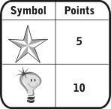

He played 6 games and for each game he got the following:

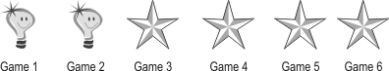

How many points did he score?

A. 6

B. 24

**C. 40**

D. 60

3. Study how the numbers are written in the boxes given below.



Following the same pattern, the numbers 13, 14, 15, 16 have to be written in the box below.



The number that should come in place of ''X'' is

A. 13. B. 14. C. 15. **D. 16.**

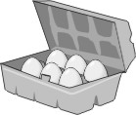4. A shopkeeper sells egg crates with 6 eggs in each.

If I want 30 eggs, how many egg crates should I ask for?

**A. 5**

B. 6

C. 24

D. 30

5. Look at the pattern on this number train:



Which number between 50 and 60 will be on this number train?

A. 52

**B. 54**

C. 56

D. 58

6. Rina has some stamps. Jiya gave her 13 more stamps. If Rina has 29 stamps now, how many did she have in the beginning?

**A. 16**

B. 26

C. 32

D. 42

7. Tia has 14 pencils and Ravi has 20 pencils. How many pencils should Ravi give away to Tia so that both of them have the same number of pencils?

A. 2

**B. 3**

C. 5

D. 6

8. 4 boys and 6 girls were sitting on a bench. Each one put 3 notebooks on the desk. In all, how many notebooks were on the desk?

A. 10

B. 13

C. 18

**D. 30**

9. See the number chart below. This is a '1 to 100' chart with three lines completed. The chart goes on the same way up to 100:

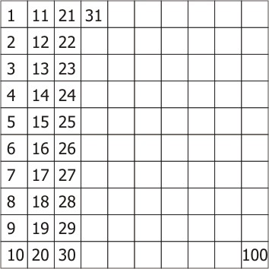

The number that comes in the box to the LEFT OF 54 in the chart is

A. 1 less than 54.

B. 1 more than 54.

**C. 10 less than 54.**

D. 10 more than 54.

10. Each bag shown below contains 10 balls.

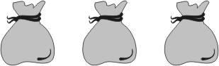

ALL the balls are taken out of the second bag. They are then put into the first bag. Totally how many balls are there in the three bags now?

A. 20

**B. 30**

C. 40

D. We cannot say without counting them again.

11. Tina is counting the number of paintings in the painting hall of her school. She has reached the 67th

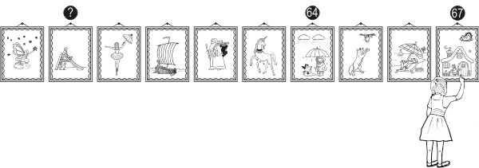painting.

What would be the number of the painting showing the question mark in the figure given?

A. 61

B. 58

**C. 59**

D. 69

12. Here are some number cards.

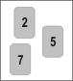

Which is the largest 2-digit number that can be formed using the number cards shown above?

A. 25

B. 57

**C. 75**

D. 99



1. D: From the contents page it can be seen that the chapter on Shapes and Patterns starts on page 69. The next chapter,

Lines, Curves and Surfaces starts on page 82. So the chapter Shapes and Patterns extends from page 69 to page 81

including both the pages. So how many pages are these? Count and see. 13!

2. C: Each star stands for 5 points and each sparkie stands for 10 points. Manav got 2 sparkies and 4 stars. The 2 sparkies

will give him 2 × 10 = 20 points and the 4 stars will give him 4 × 5 = 20 points. So he gets 20 + 20 = 40 points in all.

Remember that a star or a sparkie DOES NOT stand for 1 point each, for the total to be 6.

3. D: Study how the numbers are written in the boxes given. Can you see that the smallest of the 4 numbers is written in the

top left square, and the largest in the bottom left square? The square marked X is at the bottom left position, and so the

largest of the 4 numbers used to fill the box should come there.16 is the largest of 13, 14, 15 and 16. So 16 will come in

place of X.

4. A: Each crate contains 6 eggs, and I need 30 eggs. So I should ask for 30 ÷ 6 = 5 crates. I don't need to buy 30 crates to

get 30 eggs as there are more than 1 egg in each crate. Check that if I have 5 crates having 6 eggs each, I will have 5 × 6 =

30 eggs.

5. B: Look at the numbers in the pattern. 6, 12, 18, 24,... Can you see that 6 is added to each number to get the next

number? Can you extend the pattern, using the same rule? 6, 12, 18, 24, 30, 36, 42, 48, 54, 60, 66,...So which number

between 50 and 60 comes in the pattern? 54.

6. A: Rina has 29 stamps now. This is after Jiya gave her 13 stamps. How many stamps did Rina have before Jiya gave her

13 stamps? How do we find it? Take away the 13 stamps that Jiya gave from 29 right? 29 - 13 = 16. So Rina had 16

stamps in the beginning. It is not correct to add the numbers in any problem that has the word more. Try to understand

the problem. If Rina had 42 stamps in the beginning, and Jiya gave her 13 more, is it possible that Rina has 29 stamps

now?

7. B: Tia has 14 pencils and Ravi has 20. Suppose Ravi gives 1 pencil to Tia, how many pencils would they have now?

Ravi would have 19 pencils (20 - 1) and Tia would have 15 (14 + 1) pencils right? Now if Ravi gives 1 more pencil to

Tia, Ravi would have 18 pencils and Tia would have 16 pencils. If Ravi gives one more pencil ( the third pencil is it

not?) to Tia, what happens? Both would have 17 pencils each! So Ravi should give Tia 3 pencils so that both of them

have the same number of pencils.

8. D: 4 boys and 6 girls were sitting on a bench. So there were 4 + 6 = 10 children on the bench. Each child puts 3

notebooks on the desk. So there will be 10 × 3 = 30 notebooks on the desk. Note that 10 is the total number of children

and we have to find the total number of notebooks.

9. C: Let us take all the numbers in the first row: 1, 11, 21, 31, 41, 51, 61, 71, 81, 91. Do you see that 1 is 10 less than 11?

11 is 10 less than 21 and so on. What will be the numbers in the 4th row? 4, 14, 24, 34, 44, 54 etc. right? So the number

left to 54 is 44, which is 10 less than 54.

10. B: The total number of balls in the three bags was 10 + 10 + 10, which is 30. After all balls of the 2nd bag are put into

the first bag, the first bag will have 20 balls. The total number of balls in the three bags will be 20 + 0 + 10, which is 30.

Thus the total number of balls in the three bags remains unchanged.

11. C: If you count each painting backwards from the 67th painting, what will be the number of the painting with the question?

mark? 59, right?



12. C: We want to form the largest 2-digit using given 3 numbers 2, 5 and 7. So the number at tens place will be 7. With 2 at

tens place the numbers that can be formed are 25 and 27. With 5 at the tens place the numbers that can be formed are

52 and 57. With 7 at tens place the two numbers that can be formed are 72 and 75. 75 is the required largest 2-digit

number.